**Lesson 4 Demo 2**

**Implement Job Import Plugin**



Steps to be followed:

1. Log in to Jenkins CI tool and install Job import plugin.
2. Configure Job import plugin to import jobs from an existing Jenkins job.

**Step 1: Log in to Jenkins CI Tool and install Job import plugin.**

1. Login to Jenkins CI tool with admin user and install Job import plugin and configure it:
2. Access Plugin manager by Navigating Manage Jenkins 🡪 Manage Plugins to install Job import plugin.

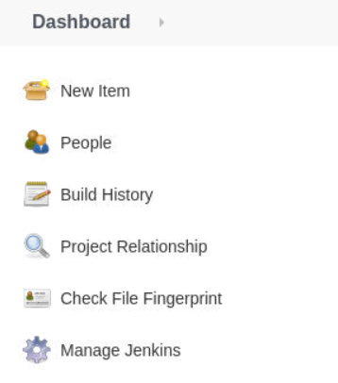

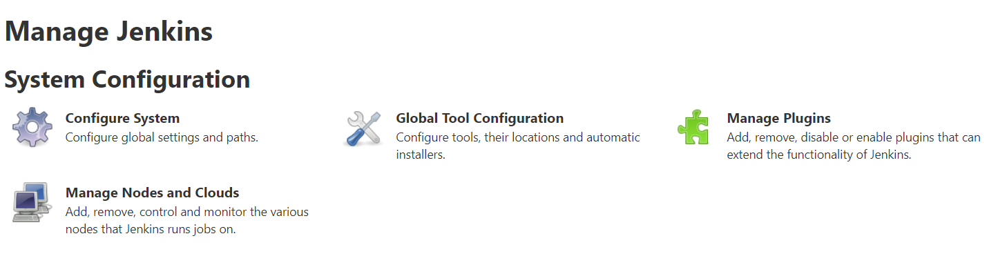

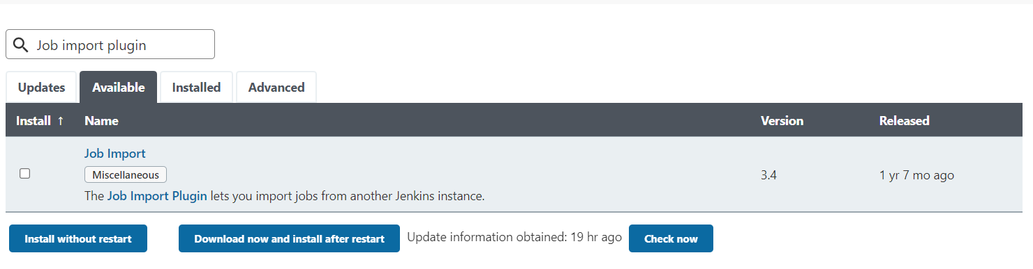

1. Once plugin is installed restart Jenkins to activate plugin in Jenkins.

**Step 2: Configure Job import plugin to import jobs from an existing Jenkins job:**

1. Access Job Import Plugin option on main Dashboard to access this plugin:

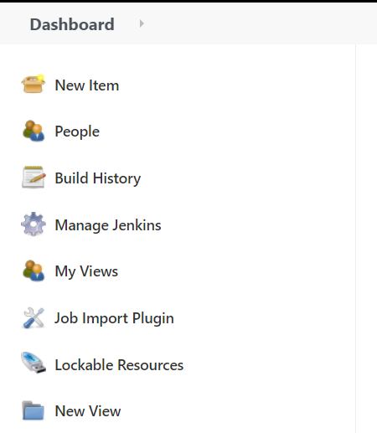

1. Before using this feature, you need to configure source Jenkins server from where you can import Jenkins’s job into existing Jenkins.
2. Navigate to Manage Jenkins 🡪 System configuration to configure old Jenkins’s information. You would see a Job Import Plugin section for configuration.

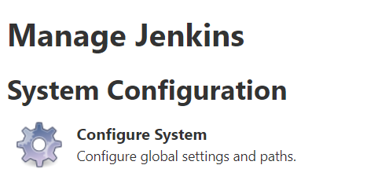

1. Before configuring Jenkins details, configure new Credential with username password for connecting Jenkins. Navigate Manage Jenkins 🡪 Manage Credentials 🡪 Create Credentials.

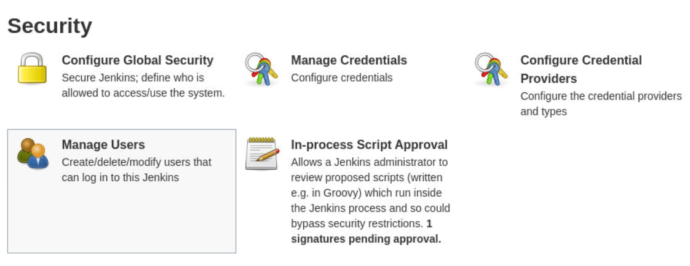

Next click on Global Domain where you can create credentials that can be accessed by Jenkins globally by any Jenkins job.

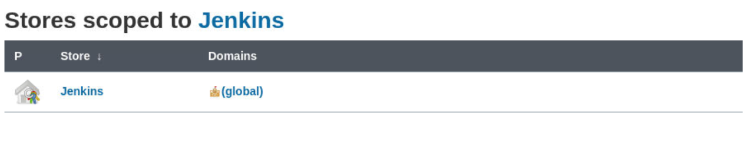

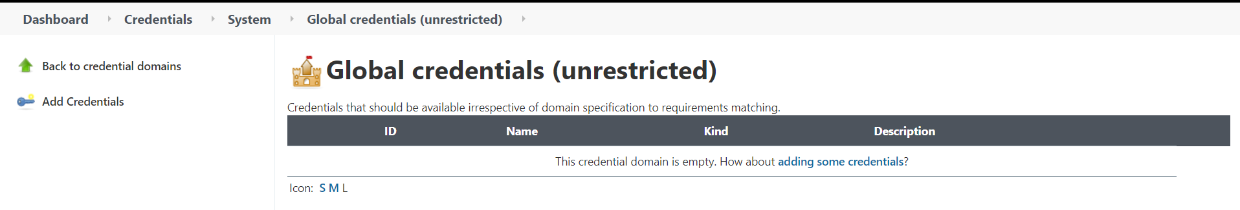

Then Click on Add credentials to add new Jenkins credentials of Username and password type.

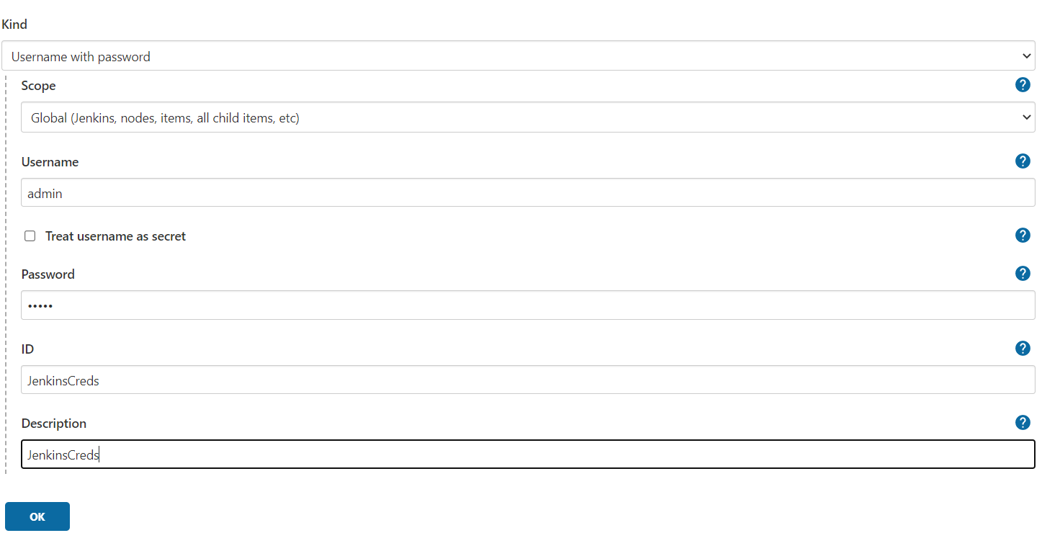

1. Next provide Jenkins’s server name, URL and credentials to connect with existing Jenkins.

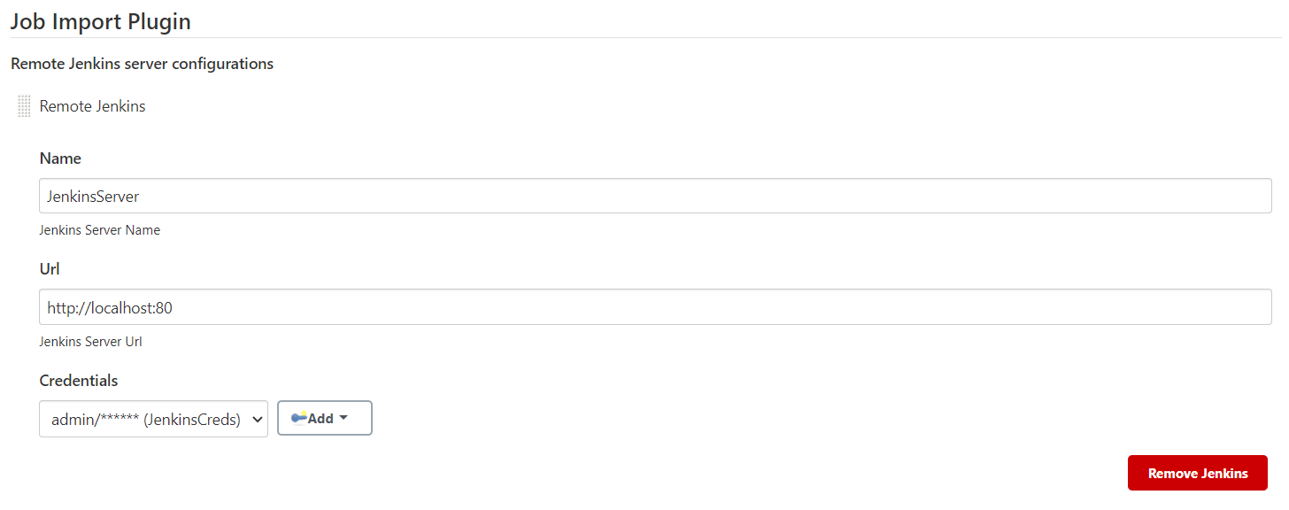

1. Once Remote Jenkins is configured you can now Access Job import Plugin option to import Jenkins job from source Jenkins.

